1. Patient

Surname*: |  |  |  | First name*:
Date of birth: |  |  |  | Gender: | M / W
Height*: |  | cm |  | Weight*: |  | kg

2. Client / Prescribing medical practitioner / Authorized person

Surname*: |  |  | First name*:
Hospital*:
Medical practice:
City:
Telephone: |  |  | FAX:
E-Mail*:

fields marked with * are obligatory

3. Details on custom-made device

3.1 Diagnosis

3.2 Anatomical position

3.3 Intended use of custom-made device / Description of intended function(s)

3.4 Additional comments (e. g. X-ray images or other imaging techniques)

3.5 Please choose a type of custom-made device and fill in the required data:

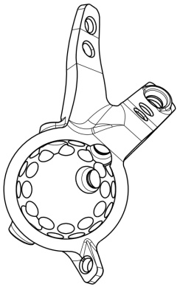  (Similar to illustration) | Partial hip replacement / Individual hip cup
 | left |  | right
 | Coating on surface that faces the bone
 | Titanium Rough Coated (TiRC) |  | yes no
Reference
CT 1mm layer thickness (total pelvis)

The custom-made device is an implant designed to be used in the hip. It is intended for continuous implantation for more than 30 days in order to restore the acetabular functional unit.

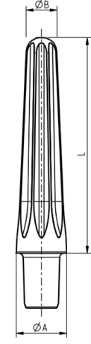 | Stem (Femur)
 | left | right
 | cementless | cemented
 | Diameters (ØA/ØB) | Ø: mm / Ø: mm
 | Lenght (L) | L: mm
 | Curved | yes no
 | Interlocking required: | yes no
Reference
CT min. 3mm layer thickness

The custom-made device is a stem designed to be coupled to existing systems of the Company Peter Brehm GmbH. It is intended for continuous implantation for more than 30 days in the femoral bone.

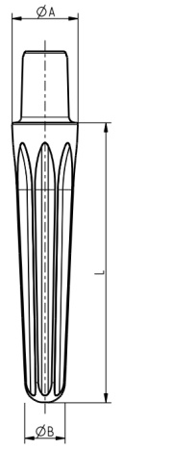 | Stem (Tibia)
 | left | right
 | cementless | cemented
 | Diameters (ØA/ØB) | Ø: mm / Ø: mm
 | Lenght (L) | L: mm
 | Curved | yes no
 | Interlocking required: | yes no
Reference
CT min. 3mm layer thickness

The custom-made device is a stem designed to be coupled to existing systems of the Company Peter Brehm GmbH. It is intended for continuous implantation for more than 30 days in the tibial bone.

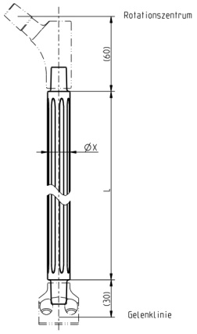 | Double cone stem straight
 | left | right
 | Diameter ( X ≥ 18mm) | Ø: mm
 | Lenght (L) | L: mm
Reference
CT min. 3mm layer thickness

The custom-made device is a femoral stem designed to be coupled to existing systems of the Company Peter Brehm GmbH. It is intended for continuous implantation for more than 30 days.

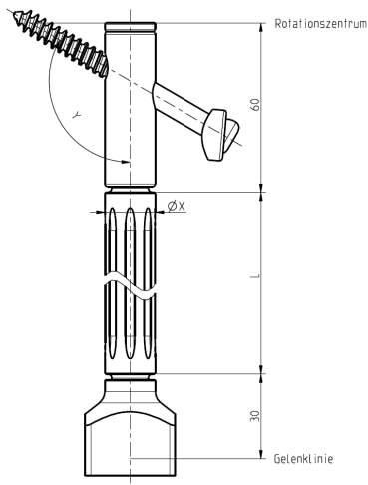 | Double cone stem straight + Femoral sleeve + Femoral neck screw
 | left |  | right
 | Diameter (X ≥ 18 mm) |  | Ø: mm
 | Length (L) |  | L: mm
 | CCD Angle (Y) |  | Y: degree
Reference
CT min. 3mm layer thickness

The custom-made device is a femoral unit designed to be coupled to existing systems of the Company Peter Brehm GmbH. It is intended for continuous implantation for more than 30 days.

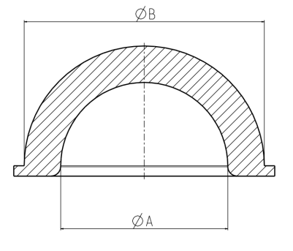 | Insert
 | left | right
 | Item number (old) if existent/known
 | Diameters (ØA/ØB) | Ø: mm / Ø: mm
Reference
Existing Implants / surgery report / surgery date / place of surgery

The custom-made device is an implant designed to be used in the hip. It is intended for replacement of a worn insert and continuous implantation for more than 30 days.

 | Other
 | (Please describe separately and detailed)

3.6 Required delivery type

Delivery type: sterile non-sterile

3.7 Required delivery date

Date |  | Signature and stamp of medical practitioner

Return enquiry to:

PETER BREHM GmbH
Sales International
Am Mühlberg 30
91085 Weisendorf
Germany
oder
E-Mail: sales.international@peter-brehm.de
Fax: +49 9135 7103 16

Agreement of manufacturer’s person in charge for custom-made devices
(Person in charge for Regulatory Affairs und Engineering Department)
Approval for realization of the custom-made device
Refusal for realization of the custom-made device

Date |  | Signature and stamp company PETER BREHM

Date |  | Signature and stamp company PETER BREHM

